Algebra 1: Unit 11, Lesson 5

- A graph of a function is shown.
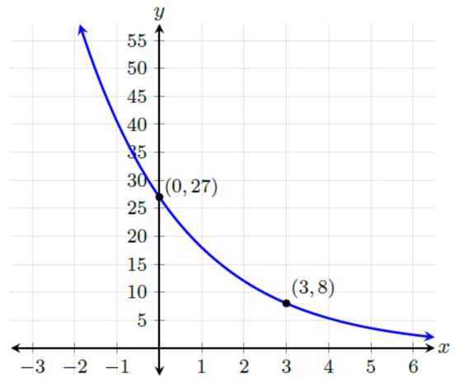
What is the $a$ value when writing the equation for the graph?
$$a=27$$

- A graph is shown.
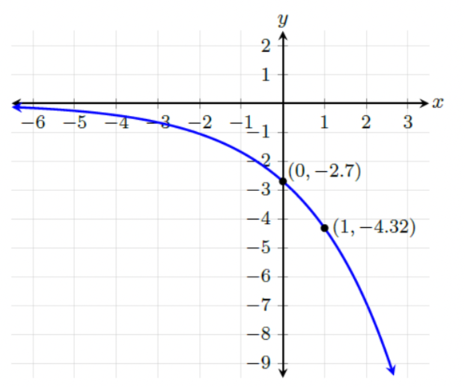
The $y$-intercept is $(0,-2.7)$ and can be used to find the $a$-value of the exponential equation. The $a$-value is $-2.7$. The second point, $(1,-4.32)$ can be substituted into the equation $y=-2.7{(b)}^{x}$ to find the $b$-value. What is the $b$ value?

$$b=1.6$$

- A table of values is shown.
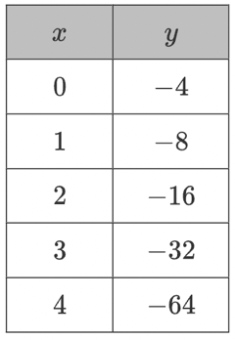
What is the equation that models the data in the table?
$$y=-4{(2)}^{x}$$

